# Create a Web App

In this exercise, you will create a simple Web App.

1. Browse to the Azure portal at https://portal.azure.com.
2. If necessary, log in with the account for your Azure subscription.
3. Click **Create a resource**.
4. Click **Web** under Azure Marketplace.
5. Click **Web App**.

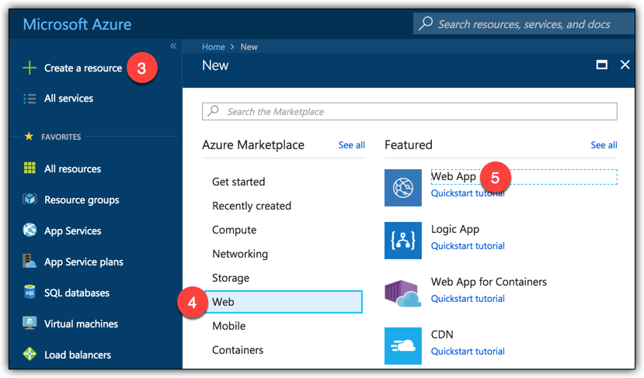

1. Enter a name for your Web App. The name must be unique. The portal will tell you if the name you’ve chosen isn’t available.
2. Under Resource Group, leave **Create new** selected and enter the name for your resource group.
3. Click on the name of the App Service Plan.

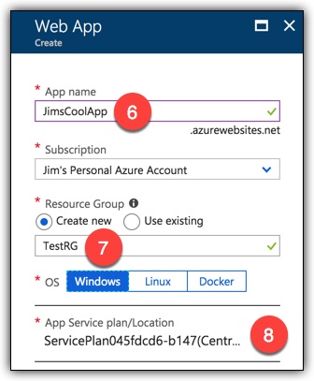

Notice that the App Service Plan that is displayed says that it’s new. This is the App Service Plan that App Service will create for you automatically. However, by clicking on the App Service Plan, you can manually create a new plan. By doing this, you can choose the name, the pricing tier, etc.

1. Click on **Create new**.

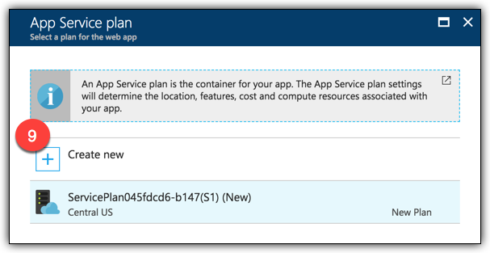

1. Enter a name for your App Service Plan.
2. Select a region.
3. Click **S1 Standard** so that you can see all the pricing tiers available.

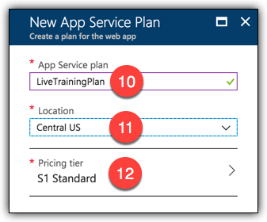

1. Select a pricing tier. Make sure that it’s at least a Standard tier so that you’ll have the features available to you that you will work with later in this course.
2. Click **Apply**.

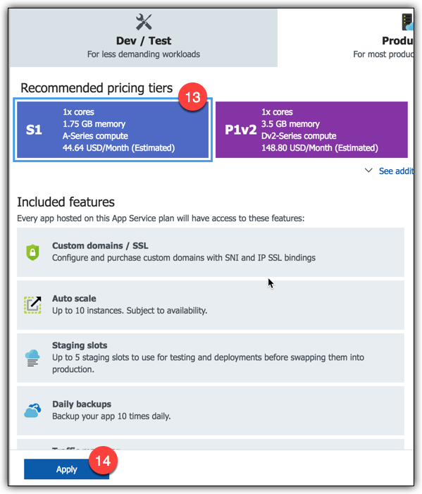

1. Click on **OK** to create your new App Service Plan.
2. Check the **Pin to dashboard** box to add a tile for your new Web App to the portal home page.
3. Click **Create** to create your Web App.

